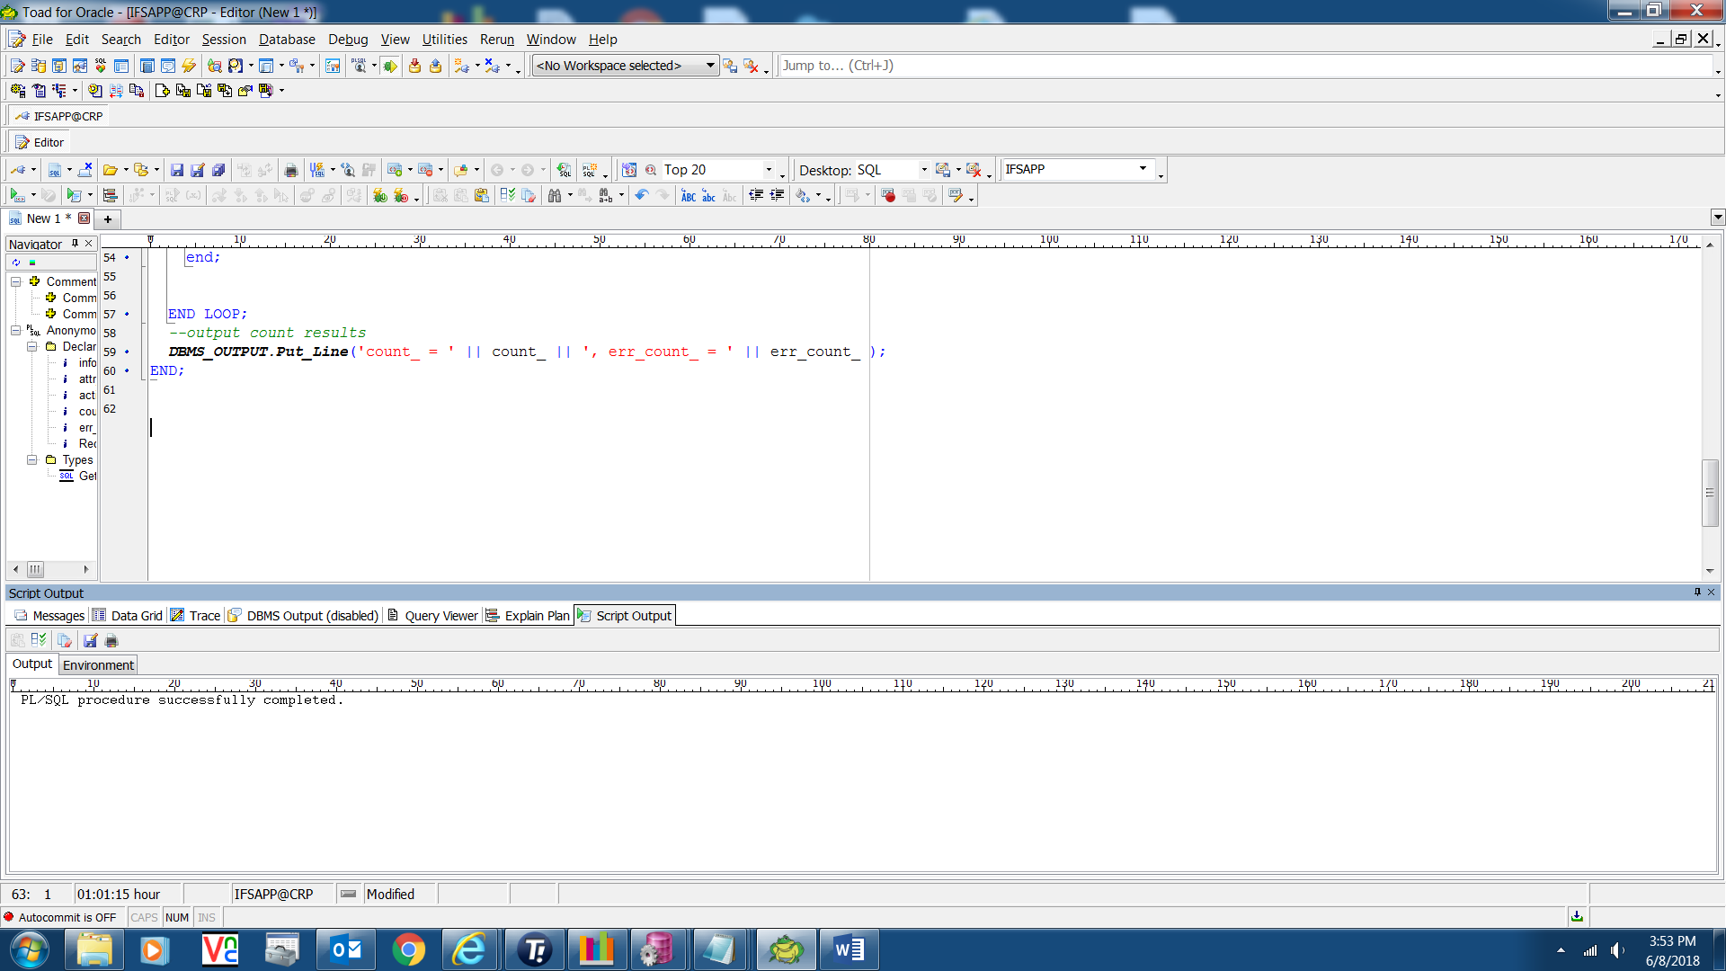

Click on the DBMS Output tab to see exceptions (This sample is update of cust master addresses to add proper county Track-It 56675)

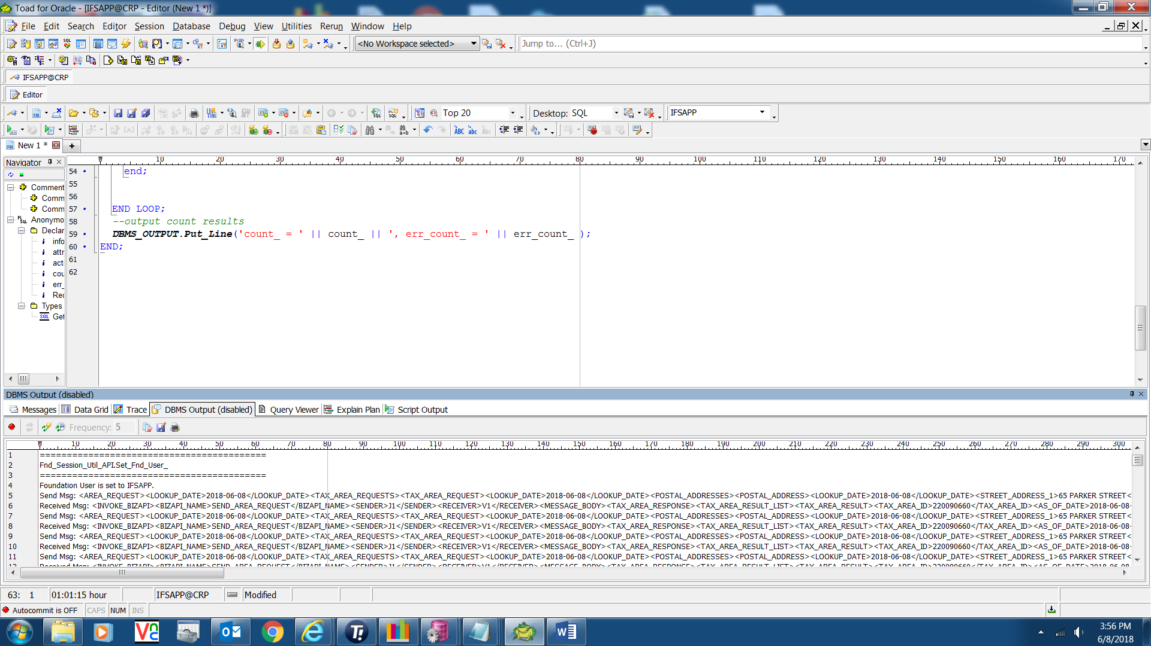

Click on little Red toggle button upper left right below messages and it will turn green.

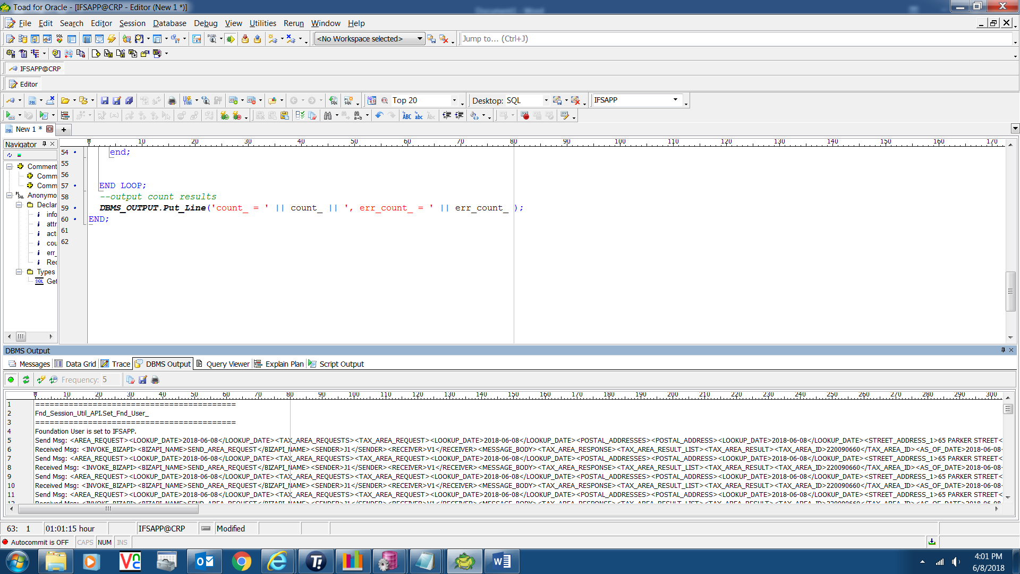

Click on Save Output To File icon

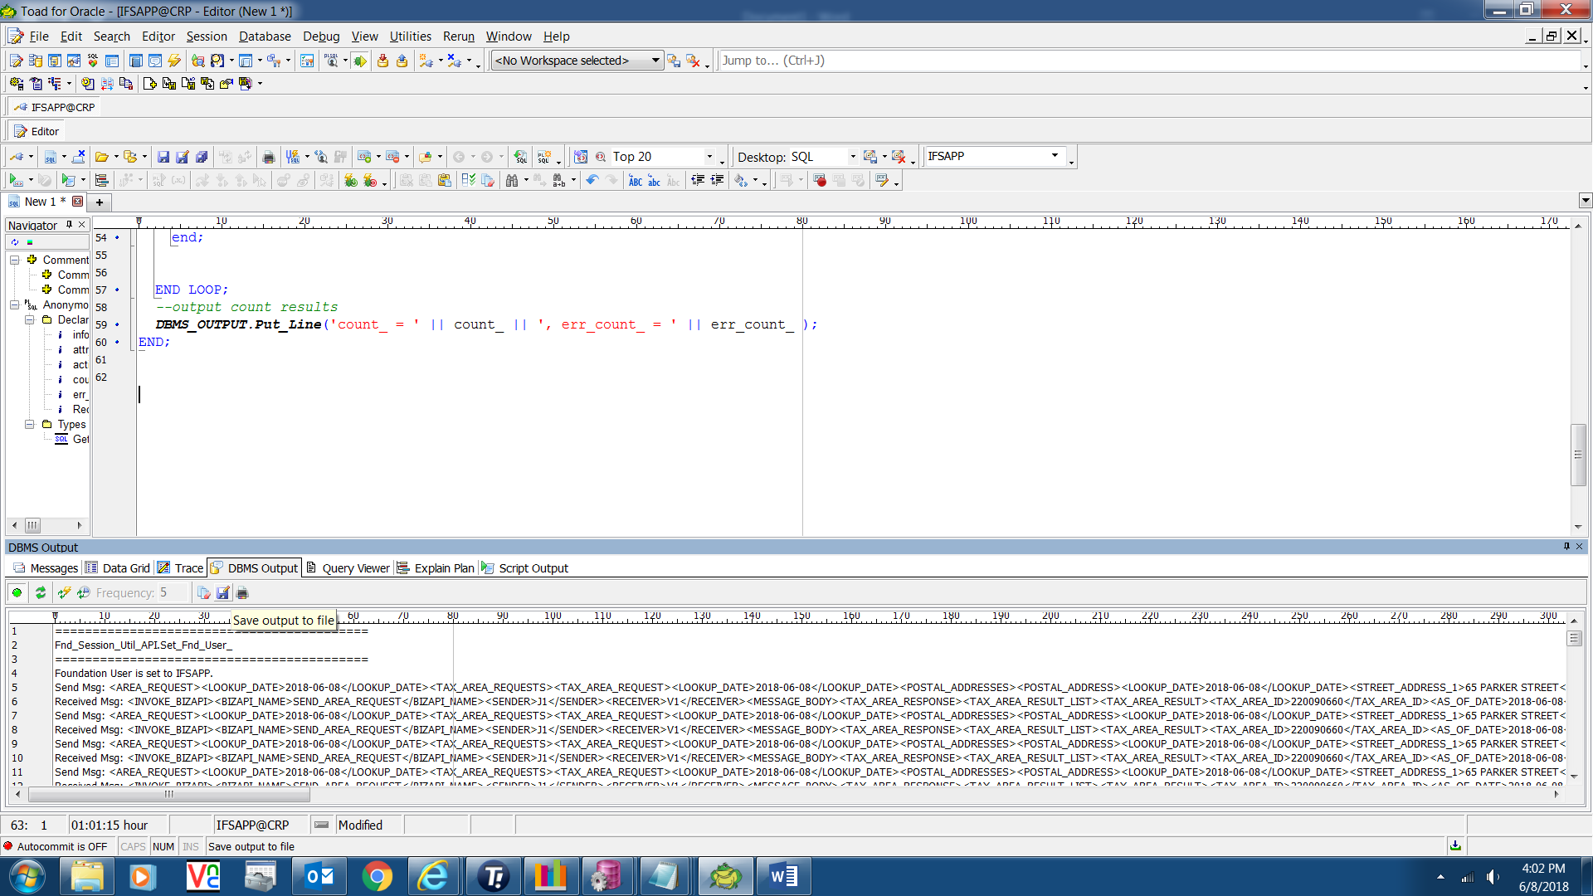

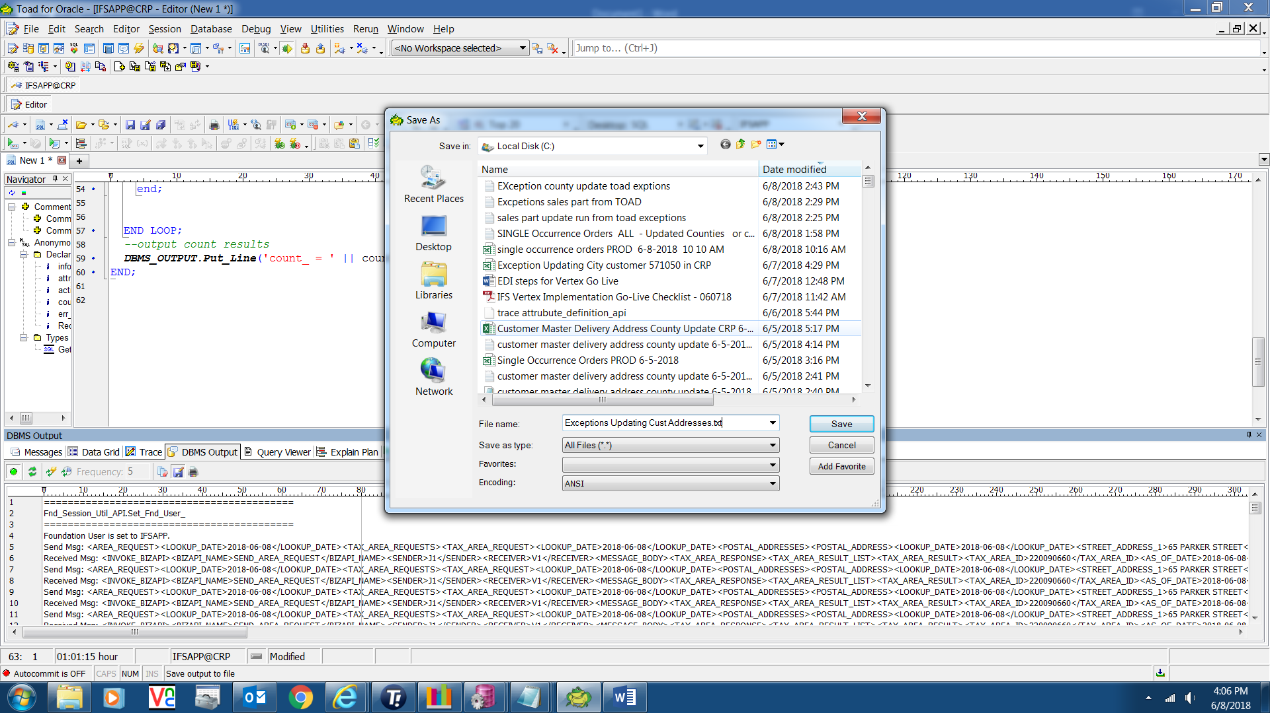

It will create the file which will be Pipe delimited and it can be imported into Excel as a delimited type file and choose Other and enter Pipe symbol. Can then sort on whatever column you wish. Save as type ALL files and name the file with .txt extension.

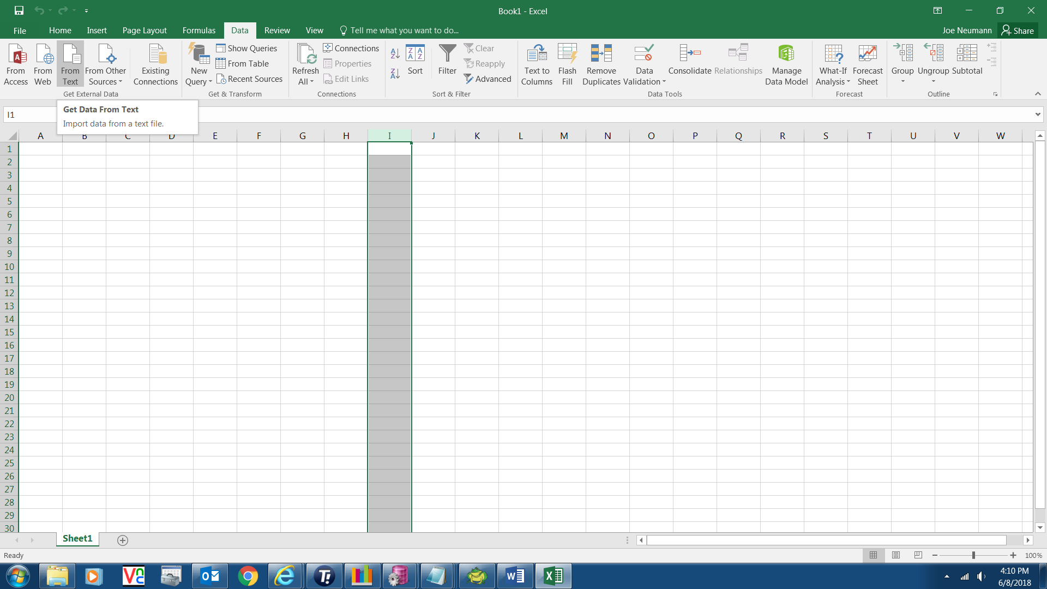

Go into Excel and select Data tab and choose From Text and go out and get the exception file you created from TOAD.

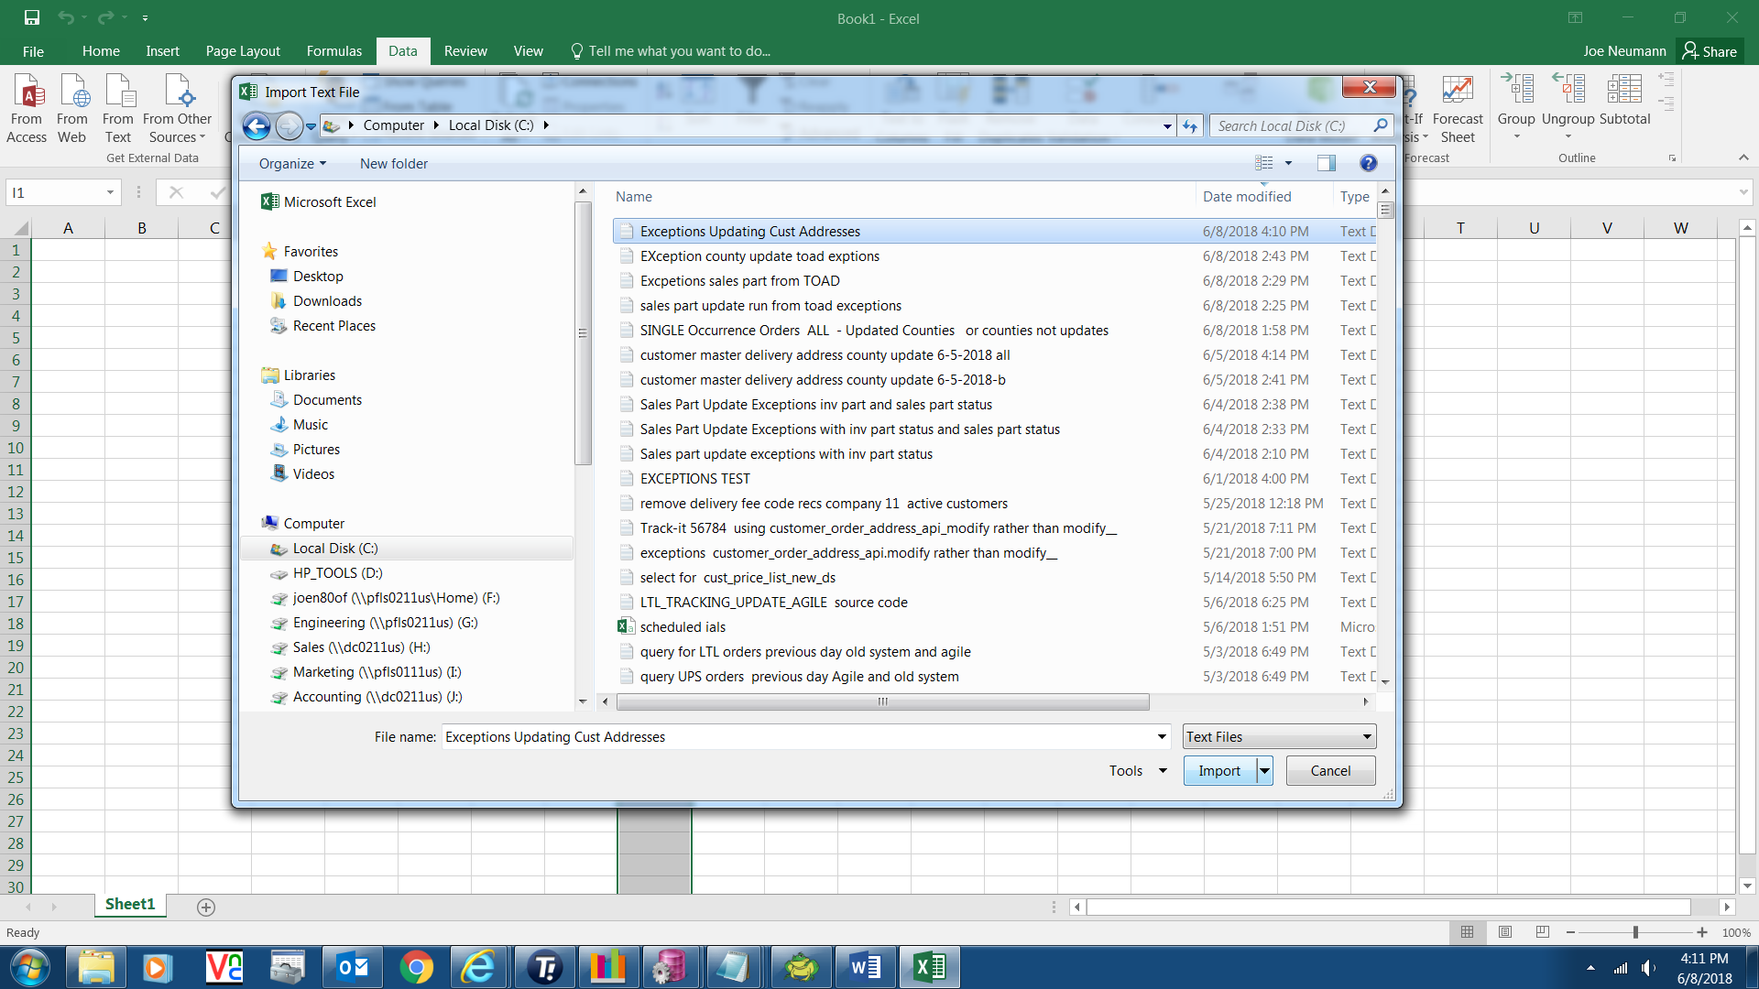

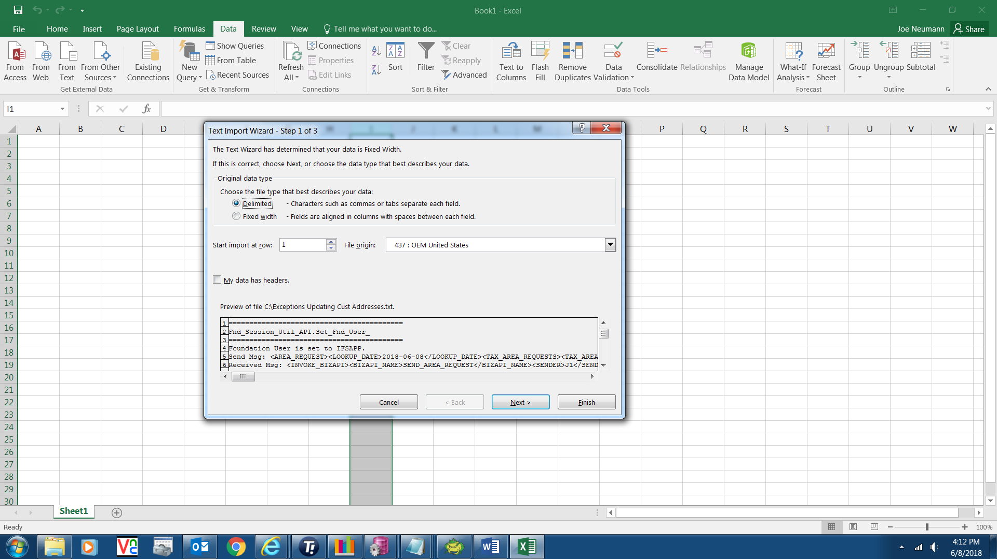

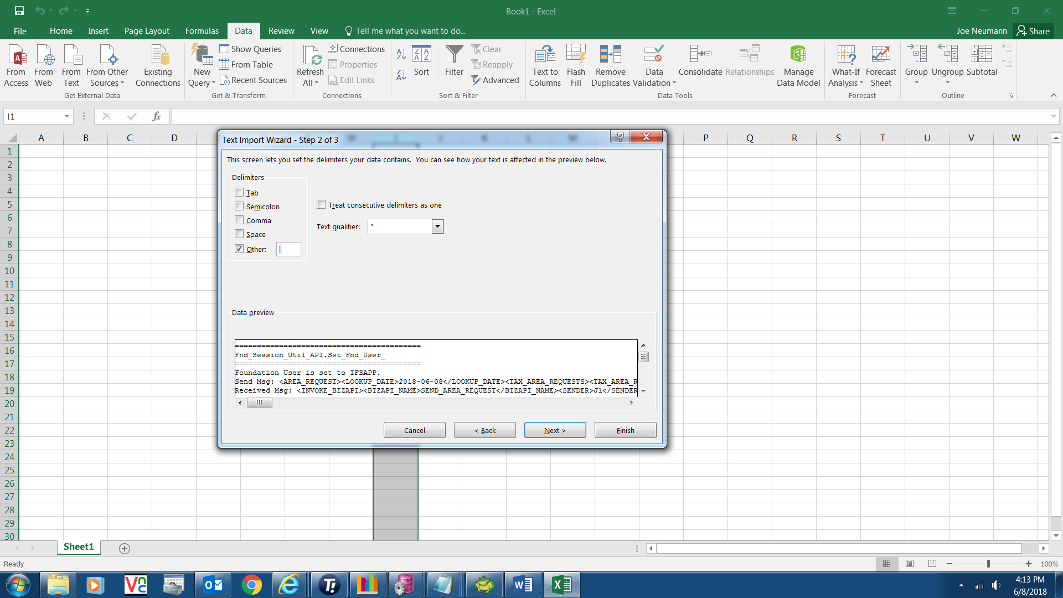

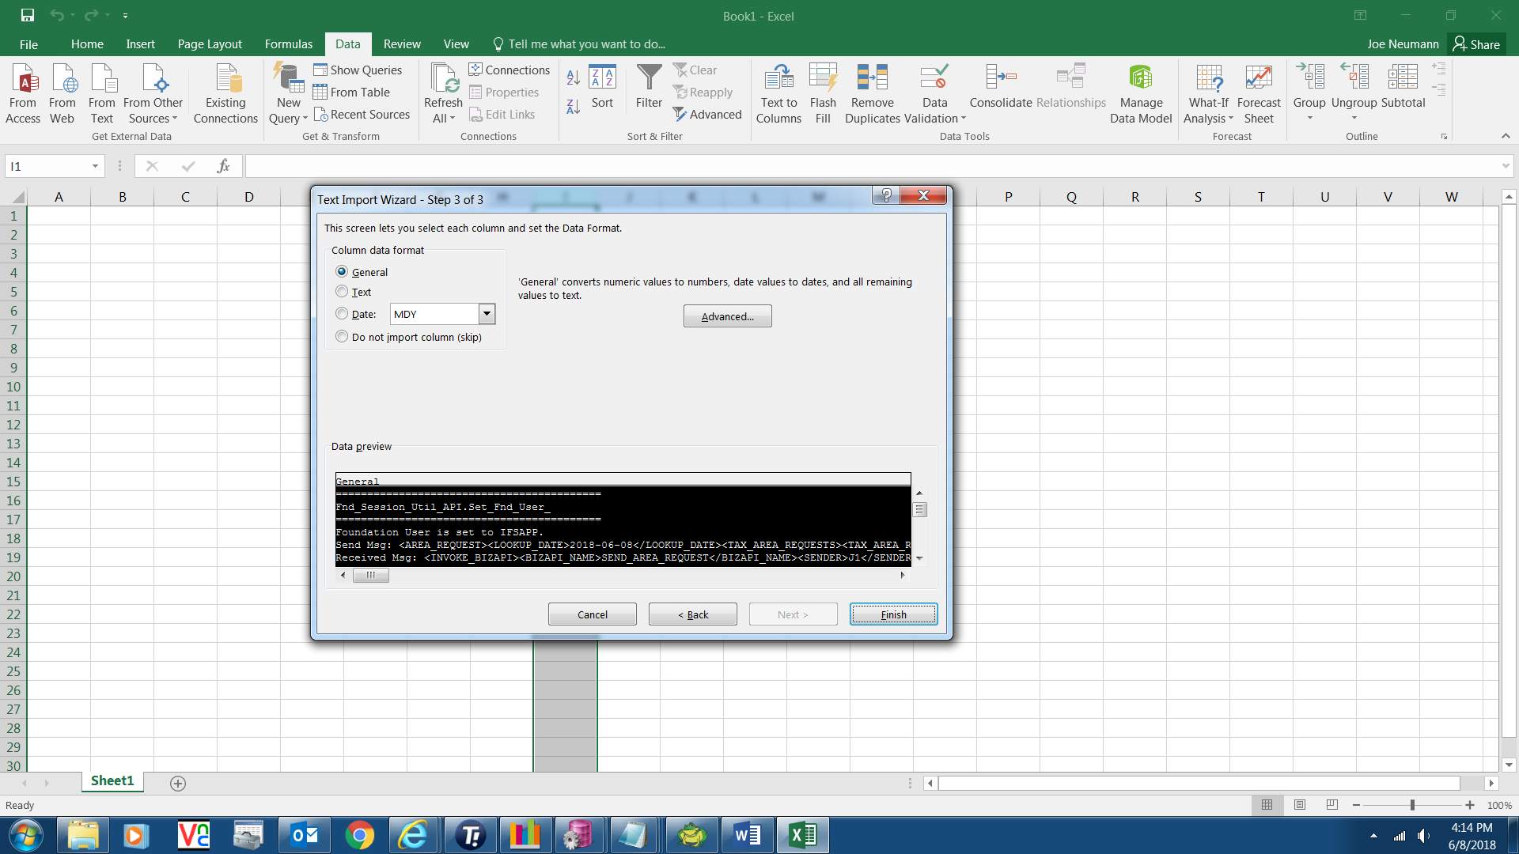

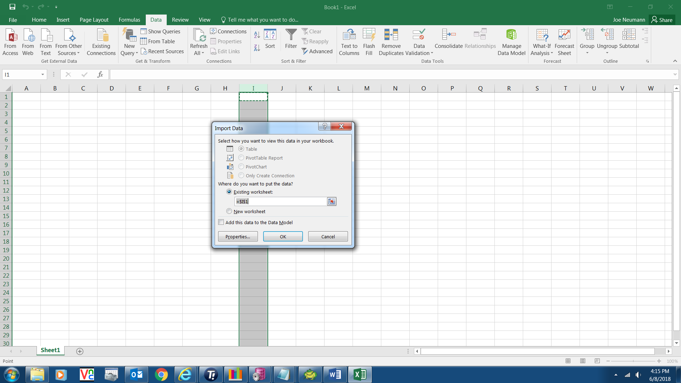

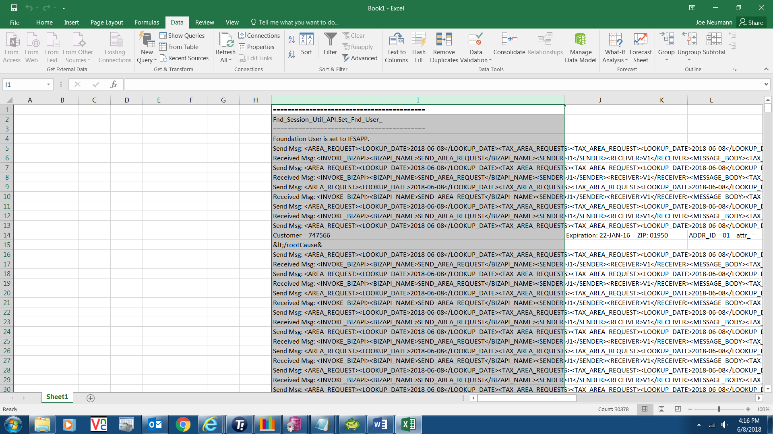

In this case it come up with columns A- H blank so I just delete those and then sorted by column A.

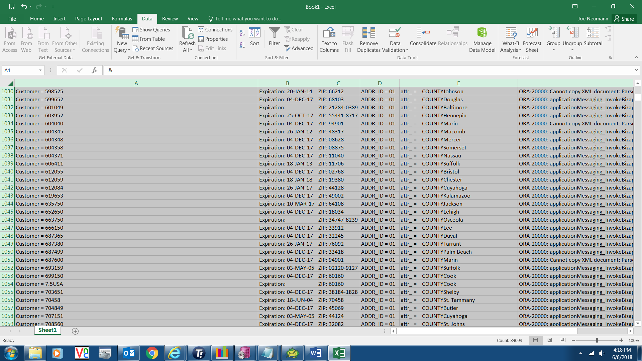

In the case of the update of customer address update for county there will be a lot of informational messages. Just scroll to the area where you see the actual exception messages I put in the script.